Joseph Roper

Salford City College | [Company address]

BTEC National 90 Credit Diploma in Creative Media Production

Unit 5: Project Reflection

Unit 5 – Project Reflection

While carrying out this project I have become more proficient in team management by having everyone in the team share all the project documents with each other so that I could see what my teammates were working on at the time and provide help. This was also useful because I could look at the work and see if anyone had not completed the task given to them and then I would follow them up on it and have them finish the work. I developed my team working skills as well by having to cooperate with my team on ideas about the podcast and often let go of some of the ideas I had as my team members disagreed with the proposal. I have also developed my conversation skills which were key to the podcast as we would have to hold up a conversation for a long period of time. I also learnt about recording software and how to record a podcast in a professional studio using expensive microphones and an audio mixer. During the project the area I contributed most in was the documentation as I was the team manager, however, I also played a key part in the actual filming of the podcast as I helped everyone choose the topic to discuss on the podcast and elaborated on that topic during the recording. Other things I did to contribute to the podcast was personally film the intro and outro to the video while James my teammate edited it. I also came up with the name of the podcast and mascot and provided creative input to the development of the mascot design.

Within the project, I acted as a team leader and spoke with each member to see what part of the project they wanted to do and assigned them that task, for example, James my teammate was very keen on editing the podcast so I allowed him to do that. However, I also had to split up the tasks that weren't very popular between the group and have each member work on some of the documentation, for example, Cameron made the Kanban and James made the questionnaire while I did the write up about our target audience demographics and psychographics etc.

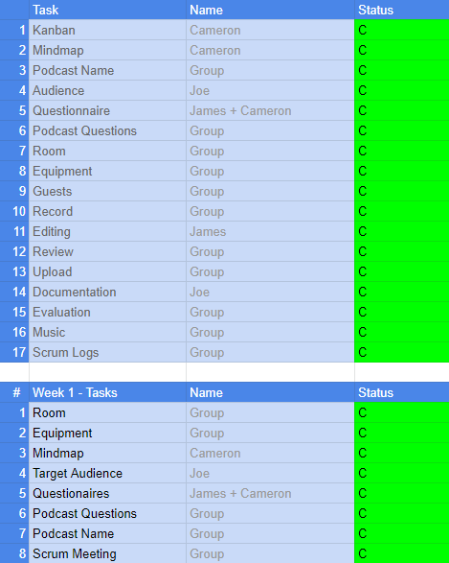

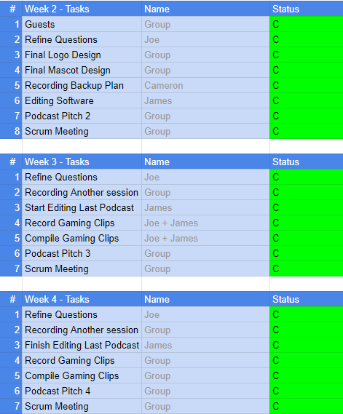

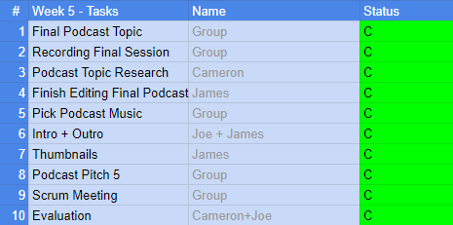

I found using the Kanban very useful as it gave the group a checklist of what needed to be completed and made sure no work was forgotten.  It also allowed me to know who was doing what so that we didn't have two people doing the same thing or someone doing nothing. I believe my personal time management for completing work during the project was great as I completed every presentation and scrum log on time during the lesson as well as updating the Kanban for the following week.

The group's time management was good as well however we had some issues with booking the recording studio in our college as the engineer kept giving our time slot away to other students, because of this many of us couldn't continue with our work as we were waiting for the podcast to be edited for example James couldn't edit with a recording and due to many of the topics I chose being time-based for example with our final podcast based on and discussing E3 (this is a gaming convention) predictions on what games will come out and what we were hoping for, we would have to record the podcast before E3. I also had to scrap some topics altogether as our time slot got taken away meaning we weren't able to record a podcast discussing the Pokémon Sword and Shield games as by the time we had a room available our enthusiasm over the topic diminished which would result in a boring podcast.

To overcome the room bookings becoming a major issue our group had a backup plan of recording the podcast at home over Discord (a program for messaging and calling people), luckily, we didn't have to use this backup as the podcast’s audio quality would have dropped as we would have had to each use the microphones in our homes which cannot contend with the professional microphones provided in the recording studio.

I believe that teamwork during the project was fantastic as we are 3 friends who are used to working on projects together. This means that I know the strengths and weaknesses of my partners and can use this information to optimize the group's productivity.

I had no real issues with my individual input during the project however for one week during the project  I couldn't attend college meaning I missed out on some tasks given to us by our teacher, for example, the task 1 writeup was given to the class to complete while I was away, because of this I had to work more during the following week to catch my group up with the documentation compared to the other groups in my class.

My project has achieved what I initially set out to do as me and my team have created and documented the process of making a podcast which matches the needs of our target audience as in our final podcast we talk about the popular gaming event E3 which relates to the interests of our target market. If I were to keep making the podcast I would re-record the intro and outro using a professional greenscreen and record the podcast video with the three of us in front of the green screen so that James the main editor of the project could do some interesting and funny things with it. I would have also liked to start slowly introducing guests onto the podcast once I and my team were confident enough to control the flow of conversation so that we don't go off topic. I would not change any management techniques if I were to continue on with the podcast as I believe the Agile method suited our group well with productivity and with the use of the Kanban we always knew what task to complete next.

If I were to work on a similar project in the future I would more or less do things the same. However, I would start recording as soon as possible and learn how to edit to help out my fellow teammates with the workload.